# Lanz Povey

**Computer Science 20S Tips**

**How to remove an unwanted Function (Private Void)**

[**http://stackoverflow.com/questions/20491653/how-do-i-delete-the-generated-function-from-accidentally-double-clicking-on-a-bu**](http://stackoverflow.com/questions/20491653/how-do-i-delete-the-generated-function-from-accidentally-double-clicking-on-a-bu)

[**http://www.tech-recipes.com/rx/23742/create-an-exit-button-in-c-visual-studio/**](http://www.tech-recipes.com/rx/23742/create-an-exit-button-in-c-visual-studio/)

[**https://www.google.ca/?gfe_rd=cr&ei=53zHVsGlIdOy8wek1b7gBQ#q=how+to+make+something+change+size+in+visual+studio+c%23**](https://www.google.ca/?gfe_rd=cr&ei=53zHVsGlIdOy8wek1b7gBQ#q=how+to+make+something+change+size+in+visual+studio+c%23)

[**https://msdn.microsoft.com/en-us/library/system.web.ui.webcontrols.fontinfo.size(v=vs.110).aspx**](https://msdn.microsoft.com/en-us/library/system.web.ui.webcontrols.fontinfo.size(v=vs.110).aspx)

[**https://www.google.ca/?gfe_rd=cr&ei=53zHVsGlIdOy8wek1b7gBQ#q=visual+studio+c%23+font+style**](https://www.google.ca/?gfe_rd=cr&ei=53zHVsGlIdOy8wek1b7gBQ#q=visual+studio+c%23+font+style)

**Method 1: Undo**

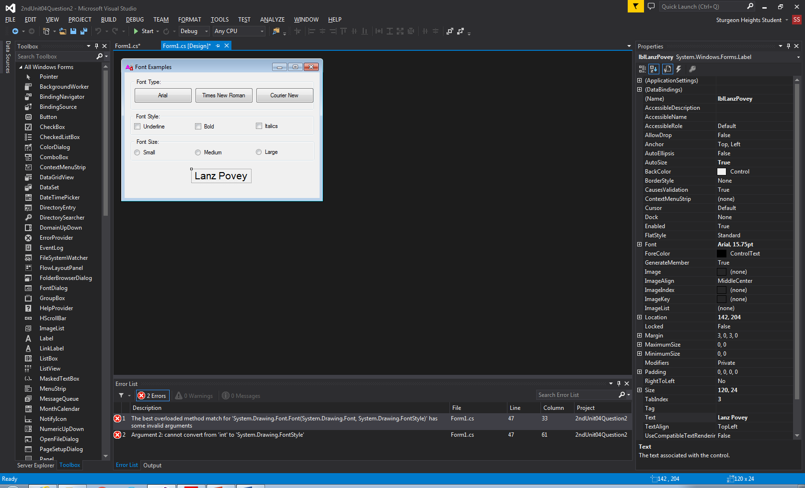

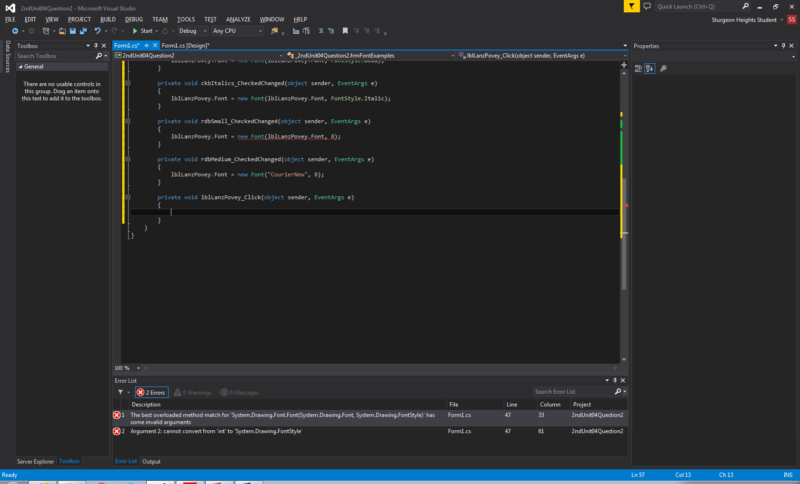

Step 1: Undo

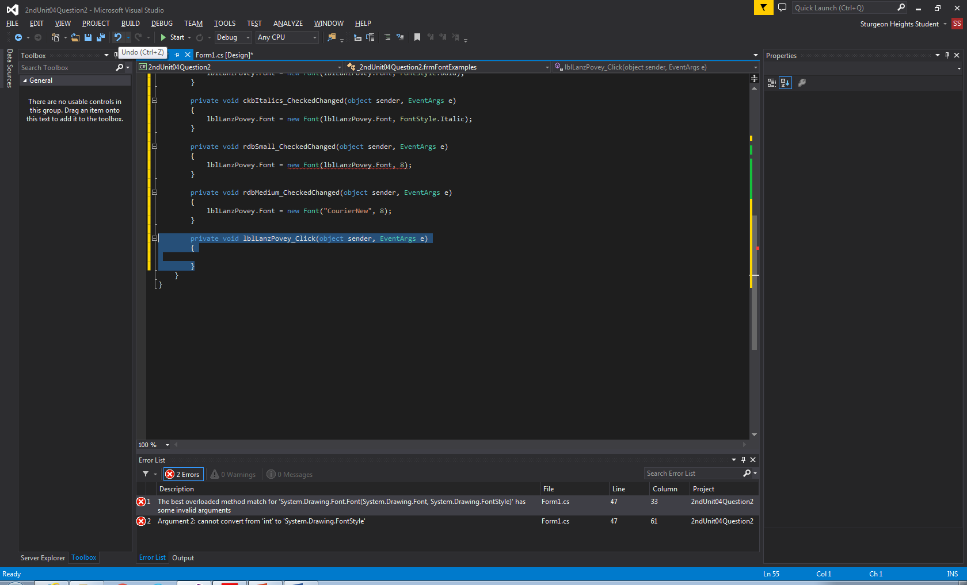

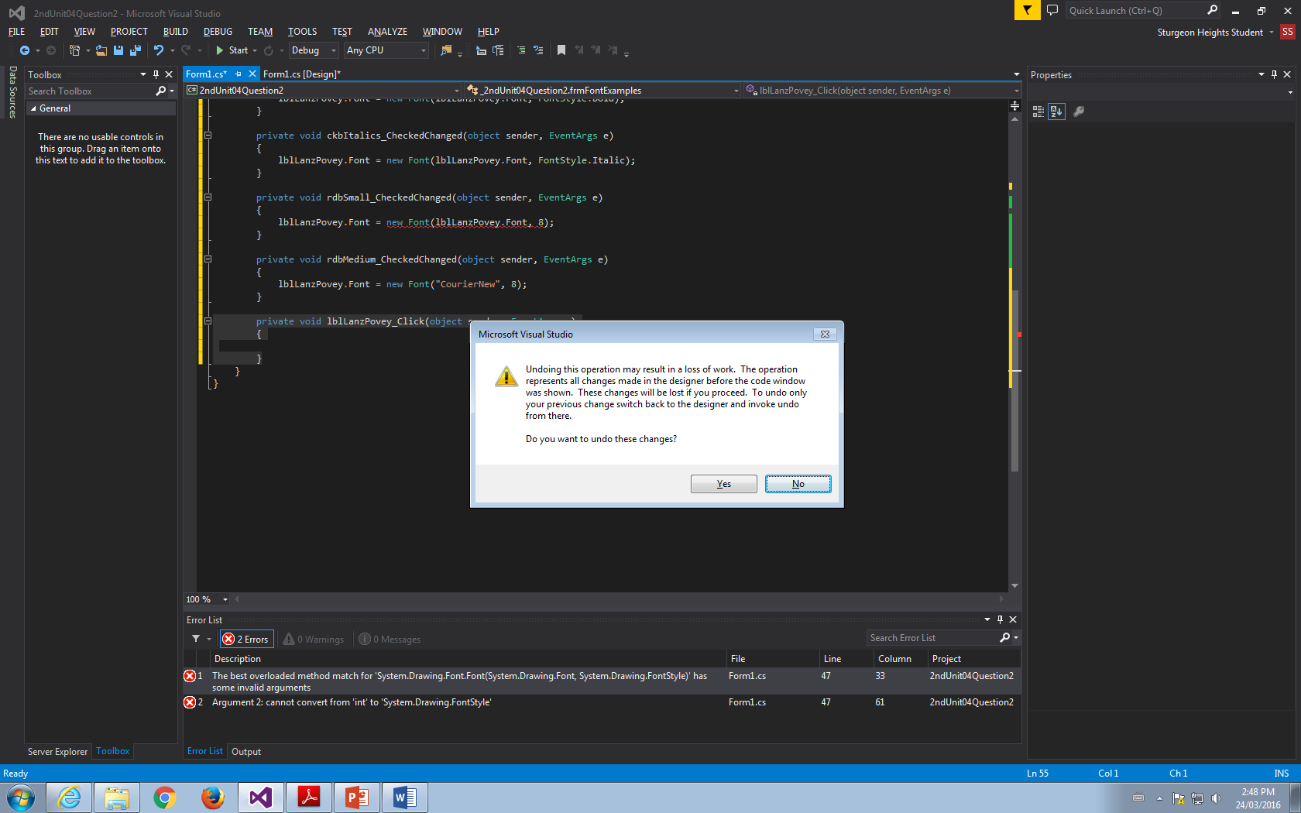

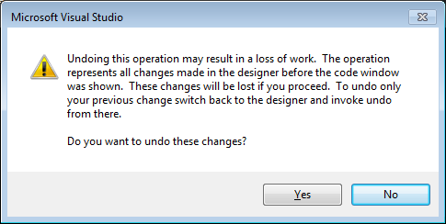

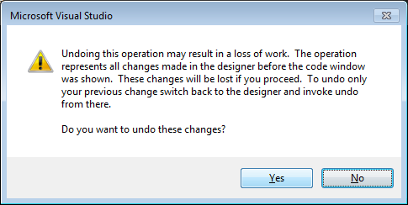

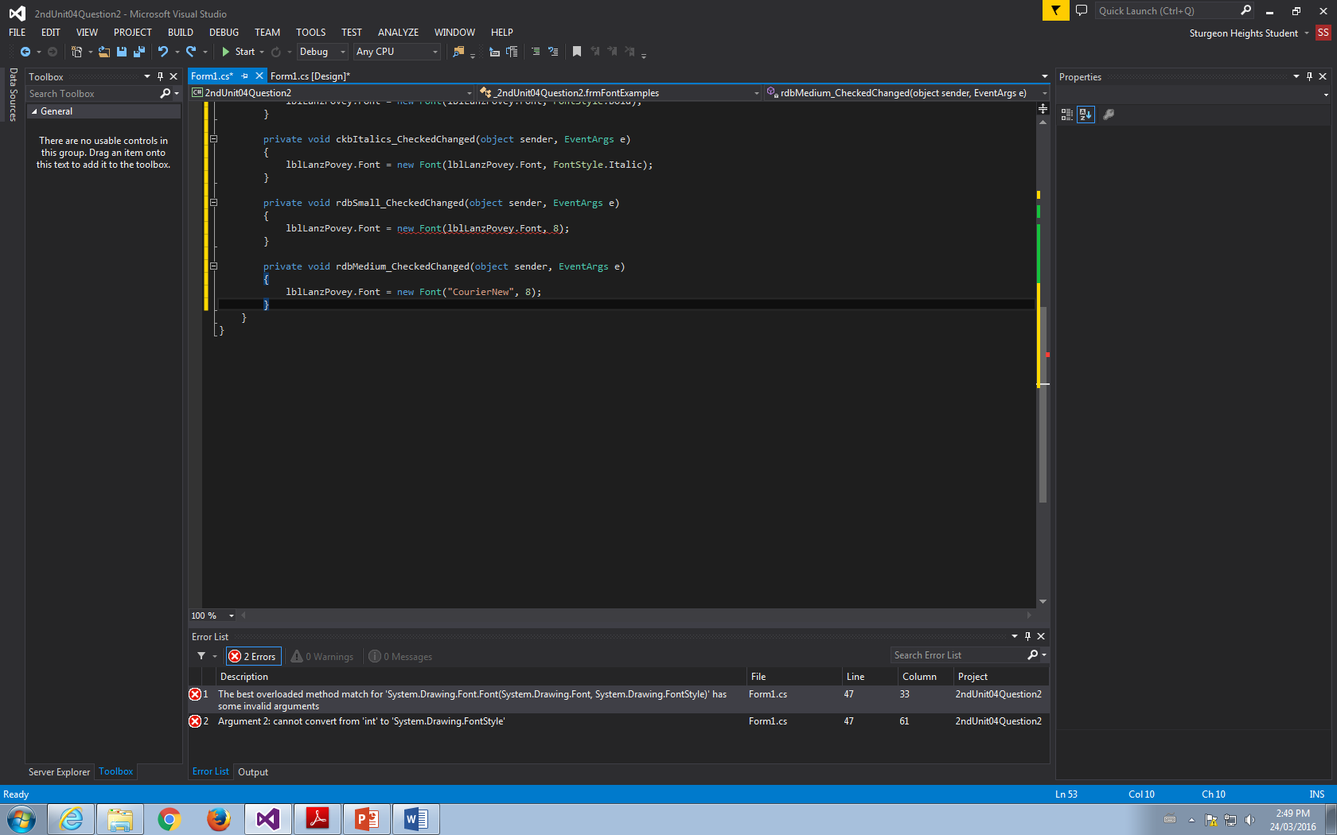

Method 2: Delete in Manually



Step 1: Locate the unwanted function

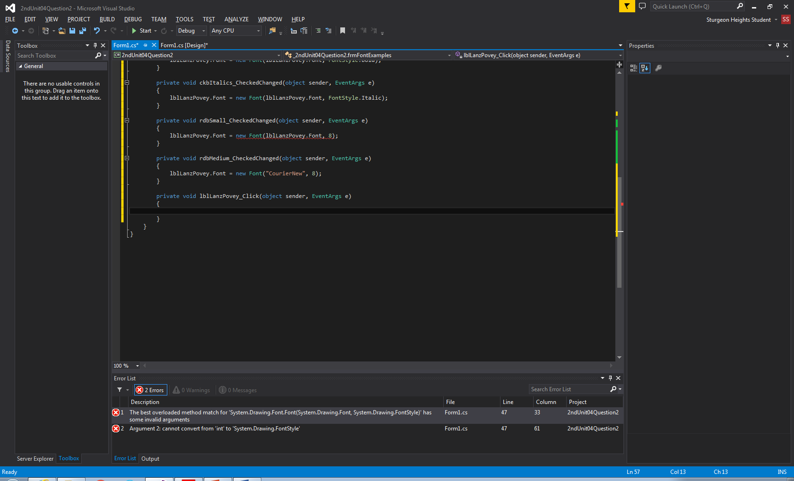

Step 2: Select all of it and delete it

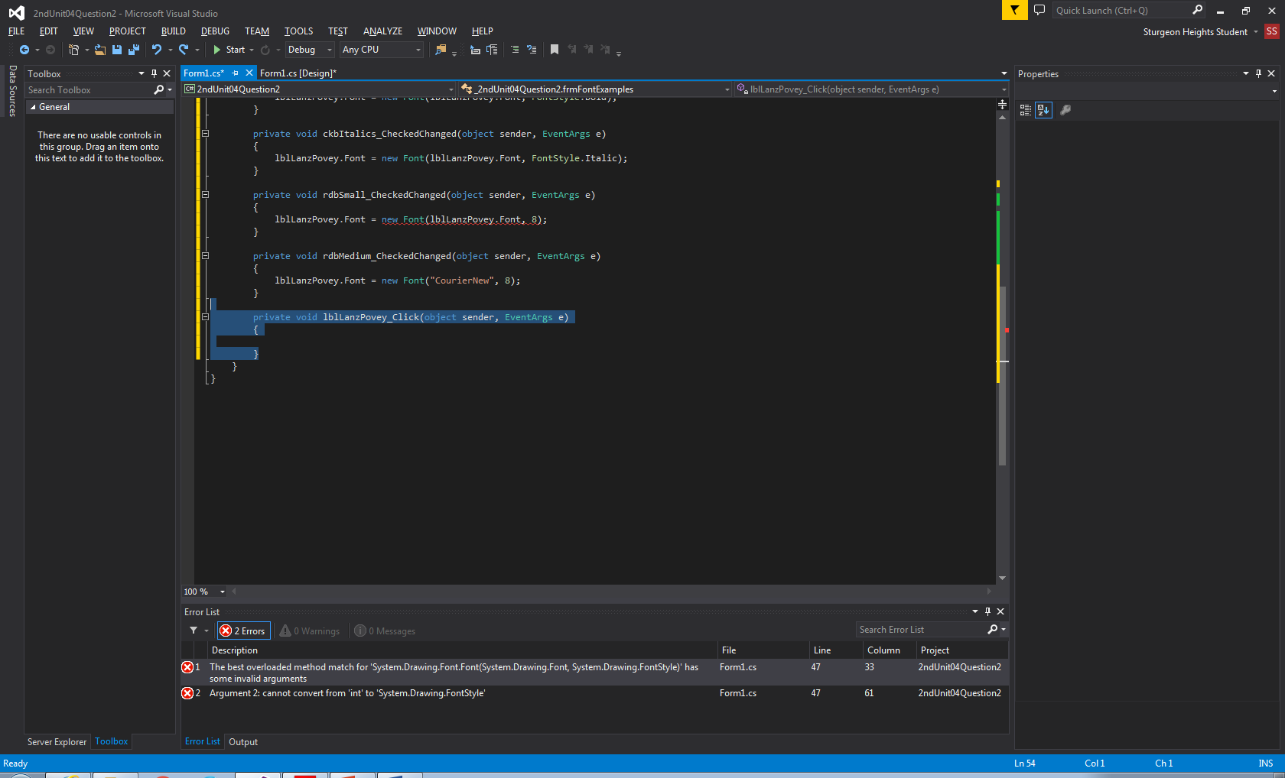

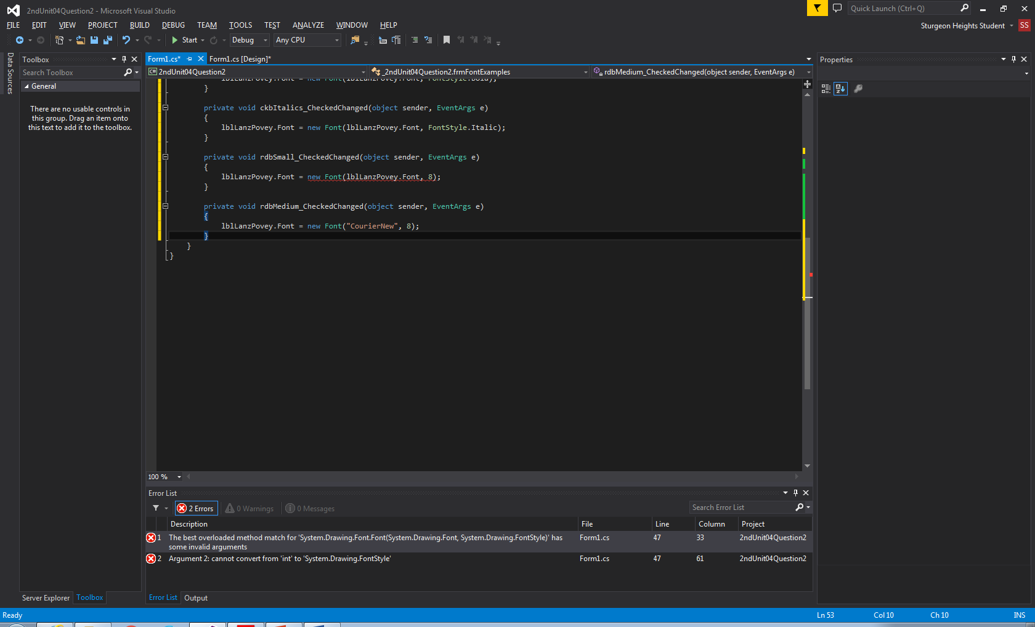

Step 3: Go to the design

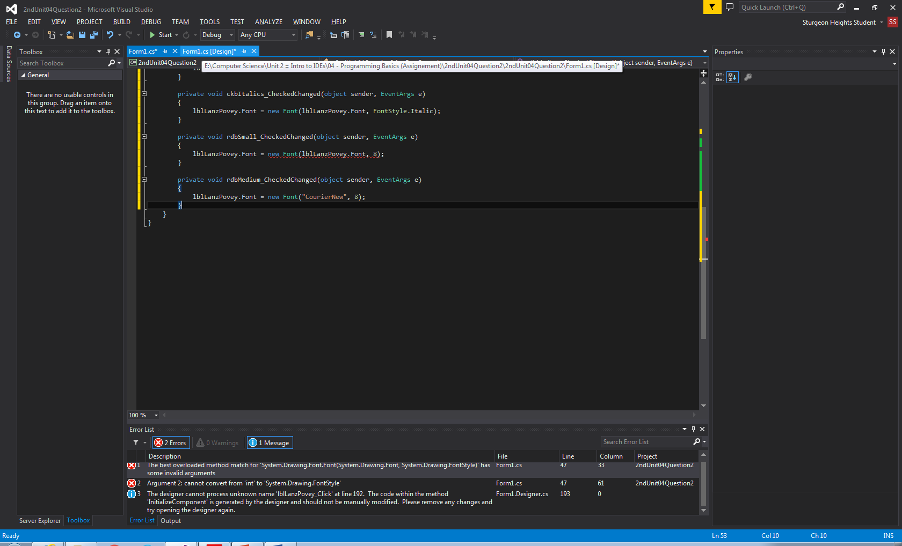

Step 4: Click on the instance of this error (1) as described by the rror message on the design.

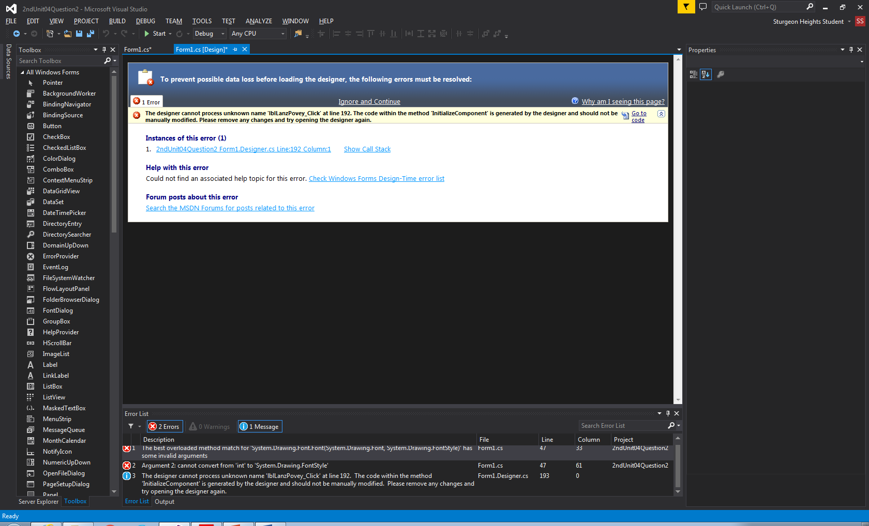

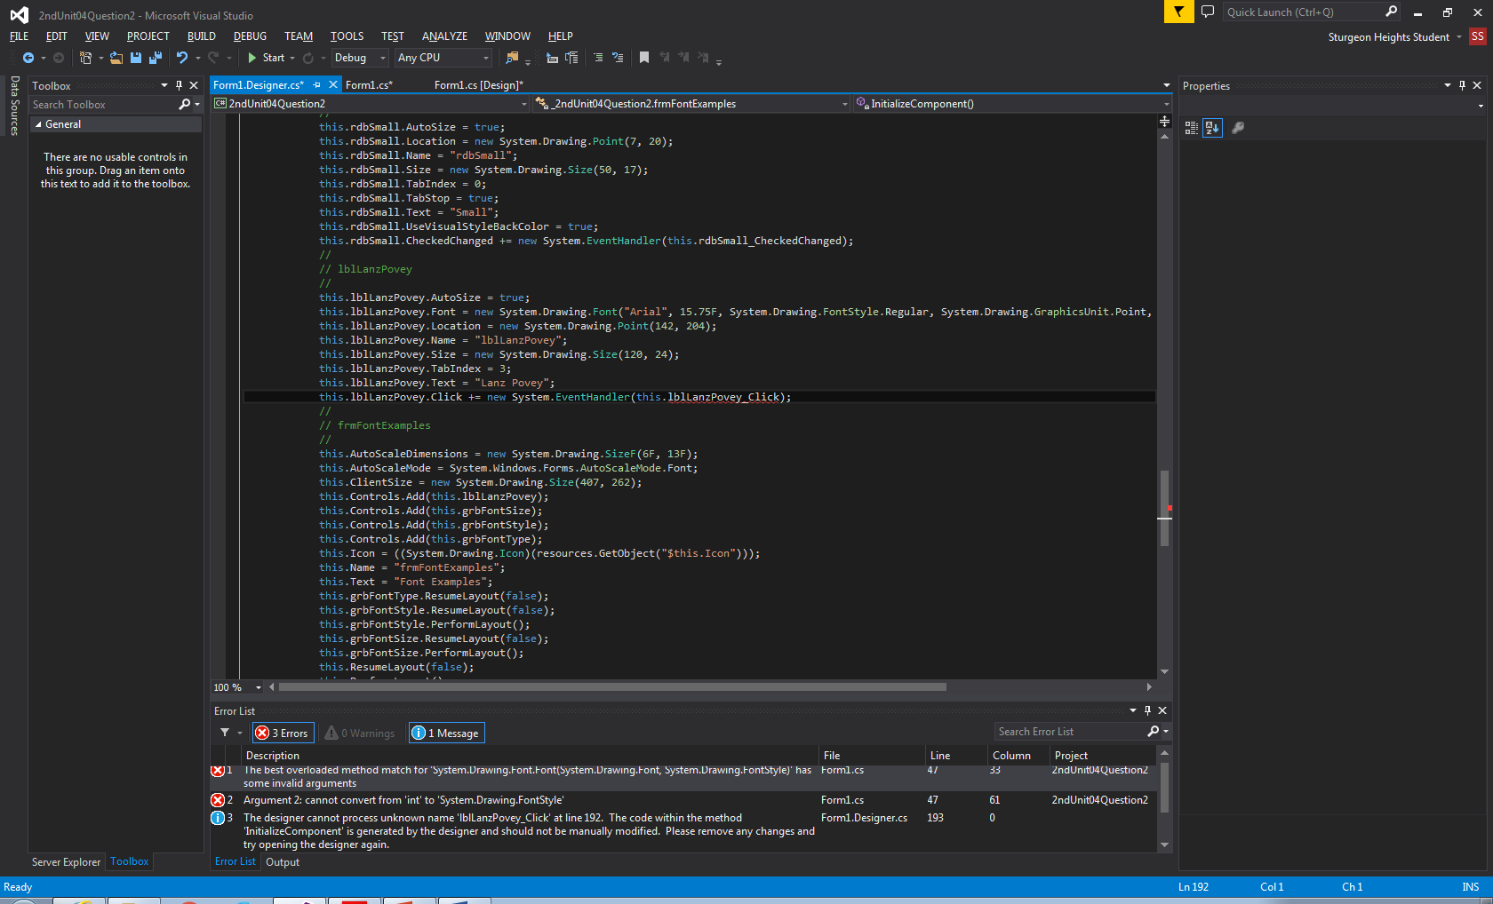

Step 4: Select all of it and delete it.

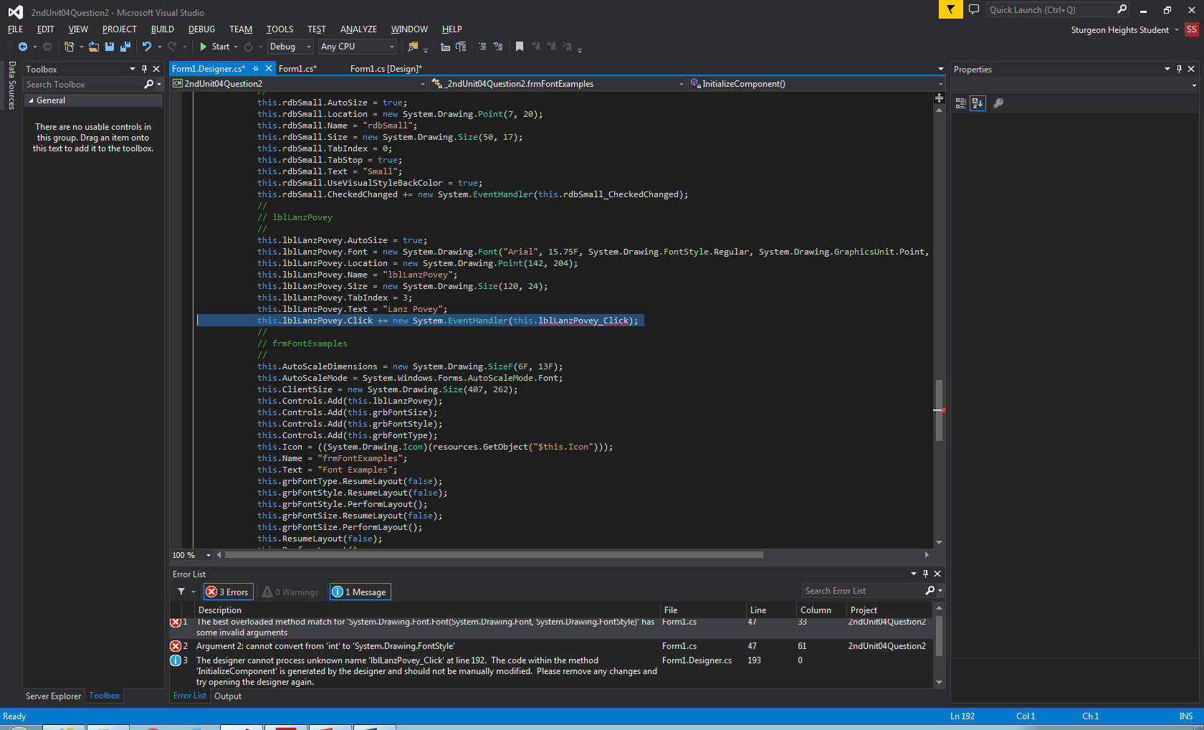

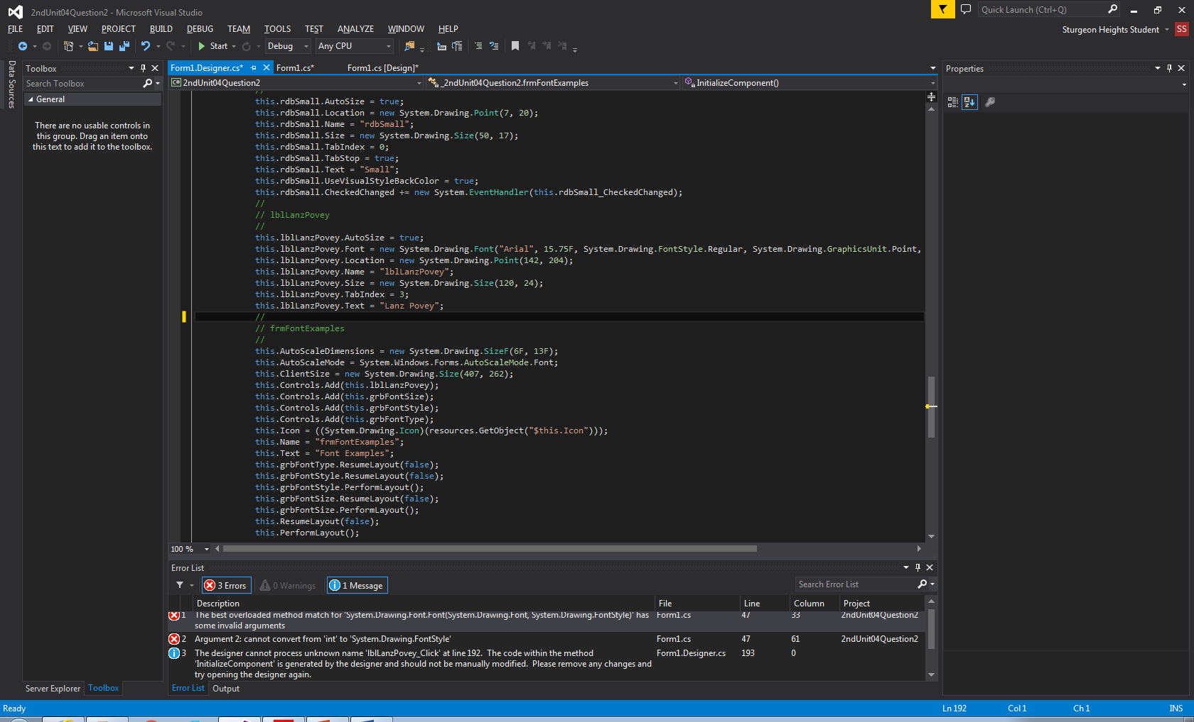

Voila! The error is now gone!

